Python Exception Handling
Exception can be said to be any abnormal condition in a program resulting to the disruption in the flow of the program.
Whenever an exception occurs the program halts the execution and thus further code is not executed. Thus exception is that error which python script is unable to tackle with.
Exception in a code can also be handled. In case it is not handled, then the code is not executed further and hence execution stops when exception occurs.

Common Exceptions
- ZeroDivisionError: Occurs when a number is divided by zero.
- NameError: It occurs when a name is not found. It may be local or global.
- IndentationError: If incorrect indentation is given.
- IOError: It occurs when Input Output operation fails.
- EOFError: It occurs when end of the file is reached and yet operations are being performed.

How to handle exception
The suspicious code can be handled by using the try block. Enclose the code which raises an exception inside the try block. The try block is followed by except statement. It is then further followed by statements which are executed during exception and in case if exception does not occur.
Syntax:
try:
malicious code
except Exception1:
execute code
except Exception2:
execute code
....
....
except ExceptionN:
execute code
else:
In case of no exception, execute the else block code.
Example
An example where we will divide a number by Zero.
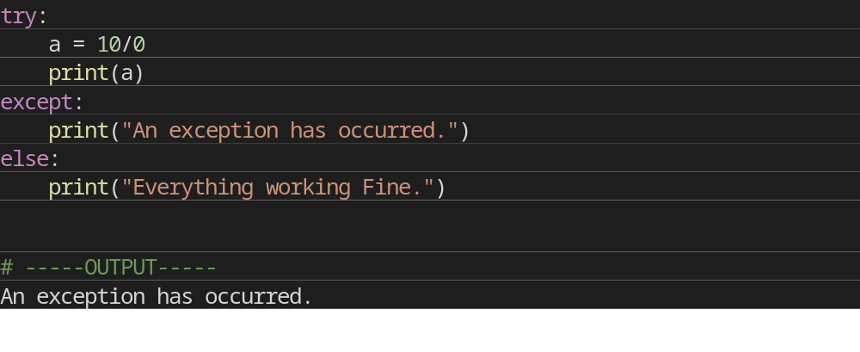
Explanation
The malicious code (code having exception) is enclosed in the try block.
Try block is followed by except statement. There can be multiple except statement with a single try block.
Except statement specifies the exception which occurred. In case that exception is occurred, the corresponding statement will be executed.
At the last you can provide else statement. It is executed when no exception is occurred. Python Exception(Except with no Exception)

Declaring Multiple Exception in Python
Python allows us to declare multiple exceptions using the same except statement.
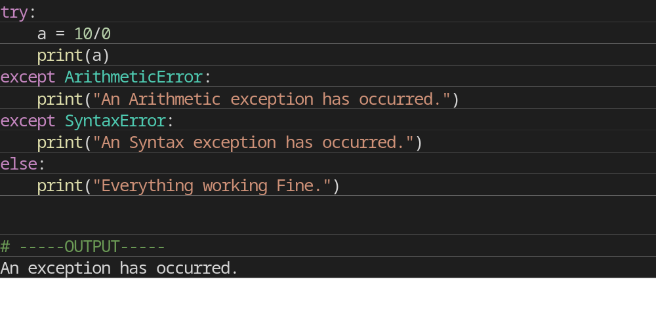
Finally Block
In case if there is any code which the user want to be executed, whether exception occurs or not then that code can be placed inside the finally block. Finally block will always be executed irrespective of the exception.
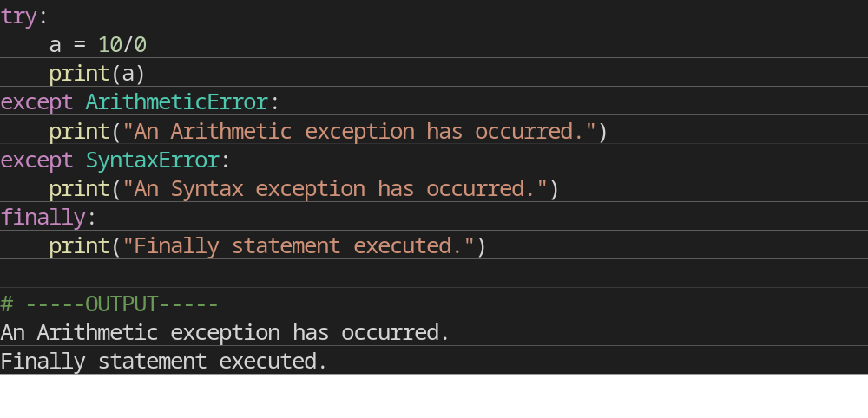
Check which exception has occurred
Python helps out to print the Exception directly.
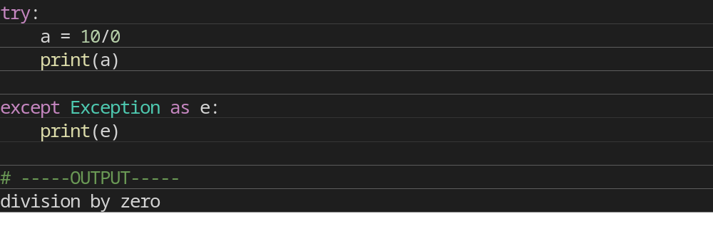

Raise an Exception
You can explicitly throw an exception in Python using raise statement. Raise will cause an exception to occur and thus execution control will stop in case it is not handled.
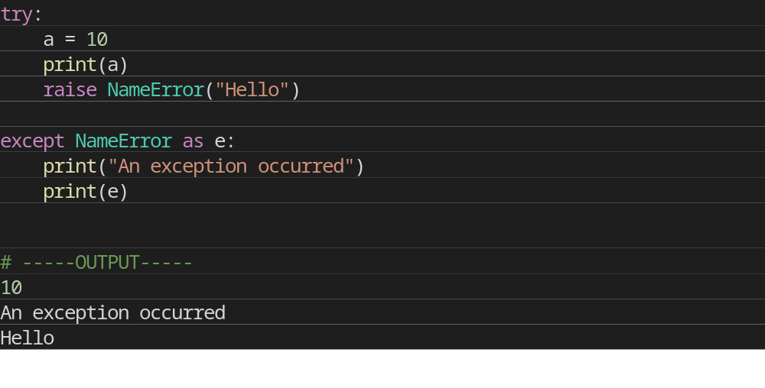
Explanation:
- To raise an exception, raise statement is used. It is followed by exception class name.
- Exception can be provided with a value that can be given in the parenthesis. (Hello)
- To access the value "as" keyword is used. "e" is used as a reference variable which stores the value of the exception.

